**Computer Programming 1  
Essential Standard 7.02 Apply One-Dimensional Arrays**

In all programs, put your name, the assignment name and the date in comments at the top.

**Walk-Through Exercises**

1. Create a project called friendsArray. The purpose of this program will be to add 5 names to the array using InputBoxes, then display those names in a label, sorted ascending.  
   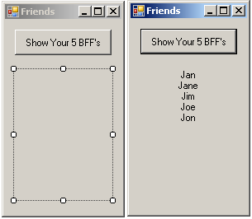
   1. In the button click, add the following code:  
        
      Dim FriendArr(4) As String 'declare the array - size 5

'Loop to add strings from InputBoxes to the array

For i As Integer = 0 To FriendArr.Length - 1

FriendArr(i) = InputBox("Enter a friend's name.", "BFF")

Next i

'Sort the array, ascending

Array.Sort(FriendArr)

'Loop to add the values from the array to the label using

‘concatenation

For i As Integer = 0 To FriendArr.Length - 1

Me.lblDisplay.Text &= FriendArr(i) & vbCrLf

Next i

1. Create a project called favoriteFoods. The purpose of this program is to add a list of your five favorite foods to an array, then display them sorted ascending. Create subs to add your values and display your values.  
   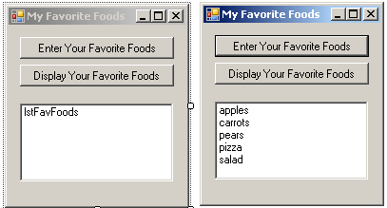
   1. Add the array declaration globally  
      Dim strFoodsArr(4) As String
   2. Add the following to create the sub to add values.

Private Sub enterFoods(ByRef strFoodsArr() As String)

'Add string values to the array

For i As Integer = 0 To strFoodsArr.Length - 1

strFoodsArr(i) = InputBox("Enter one of your favorite   
 foods", "My Favorite Foods")

Next i

End Sub

* 1. Add the following to create the sub to display the values.

Private Sub showFoods(ByVal strFoodsArr() As String)

Array.Sort(strFoodsArr)

For i As Integer = 0 To strFoodsArr.Length - 1

Me.lstFavFoods.Items.Add(strFoodsArr(i))

Next i

End Sub

* 1. Add the following code to your enter button click.

enterFoods(strFoodsArr)

* 1. Add the following code to your show button click.  
       
      showFoods(strFoodsArr)

1. Create a project called testData. The purpose of this program will be to create parallel arrays to hold student names and student test grades.  
   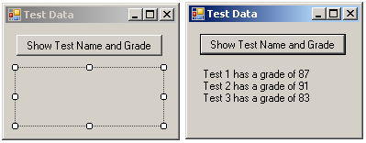
   1. Add the following code to your button click.  
      ‘Create the parallel arrays and initialize them  
      Dim testNameArr() As String = {"Test 1", "Test 2", "Test 3"}

Dim testGradeArr() As Integer = {87, 91, 83}

‘Loop to add the values from the arrays to the text in the label

For i As Integer = 0 To 2

Me.lblDisplay.Text &= testNameArr(i) & " has a grade of " & testGradeArr(i) & vbCrLf

Next i

1. Create a project called numArray. The purpose of this program will be to add 3 numbers to an array and find their average. Use Subs to add the numbers to the array.  
   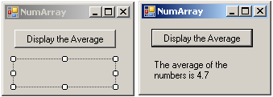
   1. Create the Sub to Add the Numbers to the Array.  
        
      ‘Sub to add values to the array  
      Private Sub addToArray(ByRef intNumArr() As Integer)

For i As Integer = 0 To intNumArr.Length - 1

intNumArr(i) = InputBox("Enter a Number")

Next i  
 End Sub

* 1. Create the function to get the average of the numbers in the array.  
       
     ‘Function to determine and return the average given the array.  
     Function getAverage(ByVal intNumArr() As Integer) As Double

Dim sum, avg As Double

For Each num As Integer In intNumArr

sum += num

Next

avg = sum / intNumArr.Length

Return avg

End Function

* 1. Add the following code in the button click to populate the array by calling the sub, and then call the function to set the value for the average and display the average in the label.

Dim intNumArr(2) As Integer

Dim average As Double

addToArray(intNumArr)

average = getAverage(intNumArr)

Me.lblDisplayAvg.Text = "The average of the numbers is " &   
 average.ToString("##.0")